Physical Science: Baking Soda and Vinegar

Activity Overview
Children make predictions about what will happen when they mix baking soda and vinegar together. They use an eyedropper as a tool to drop colored vinegar onto baking soda and observe the bubbles, fizzing, and color mixing. As they experiment with different amounts of vinegar and mixing the colors, they experience cause and effect relationships.
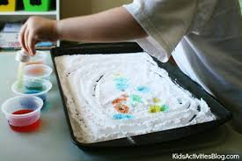
*Science process skills are in bold.

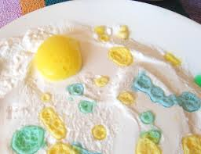
Underlying Science Concepts:
- Mixing baking soda and vinegar together creates bubbles.
- Bubbles have gas inside of them.
- New colors are made when two or more other colors are combined.

Materials
- Baking Soda
- Vinegar
- Liquid watercolors or food coloring (red, yellow, and blue)
- Small clear containers that won’t tip easily (such as large condiment cups or baby food jars)
- Eyedroppers
- Small trays (or foil pie pans or plastic plates)
- Magnifying lenses (optional)
- 1 Large clear cup or glass (8-12 oz.)
- 1 Spoon

Getting Ready
- Gather the materials for introducing the activity: bottle of vinegar, box of baking soda, small tray, 4 empty clear cups, 4 eyedroppers, liquid watercolors (red, blue, and yellow).
- Prepare one tray of baking soda for each child. Spread baking soda evenly in the tray approximately a half-inch deep.
- Make a set of clear, red, blue, and yellow colored vinegar in clear cups for each small group of four children. Mix just enough liquid watercolor or food coloring into the vinegar to make bright colors (red, blue, and yellow), neither too dark nor too light. Test out the colors to make sure they are nice and bright when dripped onto the baking soda.
- Place eyedroppers into the cups of vinegar.

Engage
- Tell the children that today they are going to experiment with two special ingredients that you bought at the grocery store.
- Show a box of baking soda and ask the children if they have seen this ingredient before. Baking soda is used in cooking, cleaning, and other uses.
- Pour some baking soda onto a tray. Ask for observations about the baking soda. (white, dry, looks like sugar, etc.)
- Show the bottle of vinegar and tell the children what it is called. Pour some vinegar into a clear cup. Ask for observations. (looks like water, clear, wet, etc.)
- Give each child a turn to smell the vinegar. (You could connect the vinegar smell to the smell of pickles.)
Some children might be familiar with baking soda and vinegar. For others, they will be new ingredients. Build off of their prior knowledge in your discussion.

- Invite them to share any previous experiences with vinegar.
- Pour vinegar into 3 more clear cups so you have a total of 4 cups of vinegar. Have the children watch as you add a small amount of liquid watercolor or food coloring to color one cup of vinegar red, one blue, and one yellow. Place a dropper in each cup of vinegar.
- Ask for predictions about what might happen when the colored vinegar is dripped onto the baking soda in the tray.
Help children understand that predictions are not about being right or wrong. Rather, making predictions is part of how scientists test their ideas.
- If they haven’t used eyedroppers before, demonstrate how to use them. Do not actually drip any vinegar onto your tray of baking soda so that the children will be able to have the experience of discovery.
- Emphasize that it is important to put droppers back into the cups they belong in so that all the mixing happens in the trays not the cups.

Explore
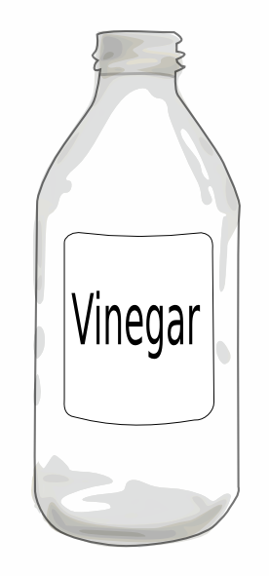
- At the activity tables, allow children to freely explore with the ingredients. They will soon discover the exciting reaction that happens when the vinegar mixes with the baking soda.
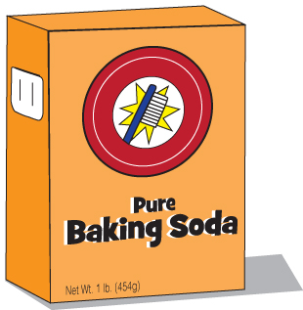
- Encourage the children to SEE the bubbles! SMELL the vinegar! LISTEN to the fizzing! All of the senses are engaged (except taste). Ask children to describe what happens as the colors mix.
- You may want to offer magnifying lenses for the children to use to observe their experiments more closely.
- Using an eyedropper is a new skill for many children, and they will need practice. Help children follow the steps: place the dropper in the vinegar, squeeze the rubber tip, let go, and then squeeze rubber tip to dispense the liquid.
  - Encourage children to use small amounts of vinegar and take their time with this activity so they can more carefully observe all of the changes taking place. Also, if the children use too much vinegar too fast, their trays will quickly become a wet mess.
Reflect
- Ask questions such as: What kinds of experiments did you do? What happened? What did you discover?
- Show the children a large clear cup (8-12 oz.) and place a tray underneath the cup. Tell them that instead of using only a little baking soda you are going to use three spoonfuls. Have the children count with you as you place 3 spoonfuls of baking soda into the cup.
- Instead of using drops of vinegar, explain that you are going to use lots of vinegar.
- Ask children for predictions about what will happen when you pour vinegar into the cup.
- Pour about a third of a cup of vinegar into the baking soda and observe what happens. Expect the children to be very excited by the fizzy, foamy result!
- This may be a good time to sing the Baking Soda and Vinegar Chant.

Baking Soda and Vinegar Chant
(Same rhythm as “Peanut Butter and Jelly” chant)
Baking, baking soda and vinegar! (Crouch down, jump up when you say “vinegar”)
Baking, baking soda and vinegar! (Crouch down, jump up when you say “vinegar”)
Mix them together, it makes lots of bubbles. (Make mixing motion with hands.)
Mix them together, it makes lots of bubbles. (Make mixing motion with hands.)
Baking, baking soda and vinegar! (Crouch down, jump up when you say “vinegar”)
Baking, baking soda and vinegar! (Crouch down, jump up when you say “vinegar”)

Teacher Tips
Depending on your goals and the children’s readiness, this activity could be part of a more in-depth exploration of solids, liquids, and gases. This activity demonstrates how a solid (baking soda) mixes with a liquid (vinegar) to make gas (bubbles).
If you do talk about gases, you can sing another verse of the Baking Soda and Vinegar chant changing the words to:
“Mix them together, it makes carbon dioxide.”

Key Vocabulary
During the activities integrate the words below into your conversations. Children’s vocabulary will build with practice.

- Baking soda  - Vinegar  - Eyedropper  - Observe  - Predict | - Experiment  - Bubble  - Fizz  - Pop  - Gas

Ideas for Further Explorations
- Repeat the same activity at another time. Children generally enjoy repeating this activity and it helps them learn that mixing baking soda and vinegar will always have the same result.
- Try combining dish soap with vinegar and baking soda.
- Experiment with dripping other acidic liquids onto baking soda, such as: cranberry juice, lemon juice, or grapefruit juice.
- Mix vinegar with other white powders (such as flour, sugar, salt, or cornstarch) and compare the different outcomes.
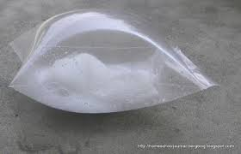
- Do cooking activities in which baking soda or vinegar is a main ingredient. For example, many recipes use baking soda to make the batter rise (muffins, cookies, pancakes).
Inflate a Bag with Baking Soda and Vinegar
This experiment is a dramatic way to observe that combining baking soda and vinegar creates gas. Let children make predictions about what they think will happen when baking soda and vinegar are sealed in the bag. They will be very excited to see the bag inflate and feel the trapped gas inside.

Materials
1 Facial tissue
1 Tablespoon (3 teaspoons) baking soda
¼ cup white vinegar
Quart-size zipper-seal plastic food storage bag

1. Lay out the facial tissue. Add 1 T. of baking soda in the middle.
2. Fold the tissue around the baking soda, making a loose pouch to contain it. (The tissue packet is to keep the baking soda from reacting immediately with the vinegar, allowing you time to seal the bag securely before the gas begins to be produced.)
3. Add ¼ cup of white vinegar to the bottom of the plastic bag. Have someone hold the bag so the vinegar doesn’t spill.
4. Drop the baking soda pouch into the bag and quickly seal the bag (an adult needs to do this step.)
5. Give each child a turn to shake the bag.
6. What's happening? Why is the bag inflating? The baking soda and vinegar combine. The chemical reaction creates a gas (carbon dioxide) that inflates the bag.

Background Information for Teachers
Vinegar and baking soda react with each other because of an acid-base reaction. Baking soda is sodium bicarbonate (NaHCO₃), a weak base, and vinegar contains acetic acid (HC₂H₃O₂), a weak acid. When mixed together, a chemical reaction takes place. A new substance, carbon dioxide gas (CO₂), is produced which causes the bubbling.

