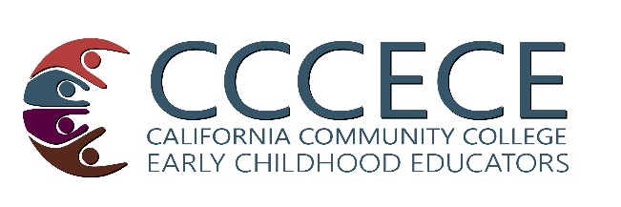 | California Community College Early Childhood Educators  Meeting Evaluation

1. How did you learn of this meeting:
□Colleague told me □Received a mailing/email □Saw a flyer/poster □Other
 | Not at all (poor) | Somewhat | Excellent
2. Was the speaker’s information valuable and relevant? | □1 □2 □3 □4 □5
3. Was the speaker(s) clear and effective? | □1 □2 □3 □4 □5
Do you have any comments or suggestions about the speaker in the Regional Meeting?
 | Not at all (poor) | Somewhat | Excellent
4. Was the topic valuable and relevant? | □1 □2 □3 □4 □5
5. Was the time allowed adequate? | □1 □2 □3 □4 □5
Do you have any comments or suggestions about the topic of the Regional Meeting?
 | No (poor) | Somewhat | Yes! Excellent
6. Will you plan on attending the next CCCECE Regional Meeting? | □1 □2 □3 □4 □5
7. Were the facilities accessible and comfortable? | □1 □2 □3 □4 □5
8. Have you attended previous CCCECE Regional Meetings or Institutes?
□This is my first □About Once a year □I attend every meeting
Do you have any comments or suggestions for future CCCECE Regional Meetings or Institutes?
9. Are you a CCCECE member?
□Yes! □I just joined today □Not yet
10. Do you attend the CCCECE Meeting at the CAEYC Conference?
□I haven’t yet □Some years □Every year □There’s a meeting at CAEYC?
Do you have any comments or suggestions for us about CCCECE or our activities?
Optional: please tell us how to get in touch with you to follow up on your ideas:
Your name ___________________________________ College/Institution ________________

Your phone __________________________________ Email __________________________
Thank you for participating in today’s event and taking the time to share your ideas with us!

